UNIVERSITY OF WAH (UOW)

DEPARTMENT OF COMPUTER SCIENCE



BSCS 3RD B

REG #: UW-24-CS-BS-088

SUBMITTED BY: SAADI SAFDAR

SUBMITTED TO: Ms. MUNNIBA KHAN

COURSE TITLE: DATA STRUCTURES

COURSE CODE: CS – 201 L

LAB REPORT # 4

Assigned tasks in lab:
1.
#include<iostream>
using namespace std;
int main()
{
int arr[50], size, pos;
cout<<"Enter array size: ";
cin>>size;

cout<<"Enter array elements: ";
for(int i=0; i<size; i++)
{
cin>>arr[i];
}
cout<<"Enter position where you want to insert: ";
cin>>pos;
for( int i=size; i>pos; i--)
{
arr[i]=arr[i-1];
}
size++;
arr[pos]=25;
cout<<"New array elements are: ";
for(int i=0; i<size; i++)
{
cout<<arr[i]<<" ";
}
return 0;
}

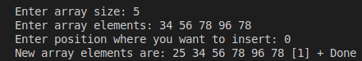

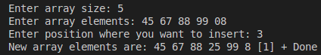

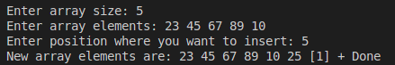
2.
#include<iostream>
#include<stdlib.h>
using namespace std;
int main()
{
int arr[100], s, k;
for(int i=0; i<100; i++)
{
arr[i]=rand()%100;
cout<<"array["<<i<<"]"<<arr[i]<<endl;
}
cout<<"Enter a value to search in array: ";
cin>>s;
for(int j=0; j<100; j++)
{
if(s == arr[j])
{
cout<<"\nNumber found at array["<<j<<"]";
k=1;
}
}
if(k == 0)
{
cout<<"Number not found"<<endl;
}
return 0;
}
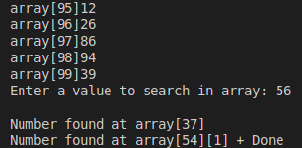

3.
#include<iostream>
#include<stdlib.h>
using namespace std;
int main()
{
int arr[100], hv, lv;
cout<<"Enter five values: ";
for(int i=0; i<5; i++)
{
cin>>arr[i];
}
hv = arr[0];
lv = arr[0];
for(int j=0; j<5; j++)
{
if(arr[j]>hv)
{
hv = arr[j];
}
if(arr[j]<lv)
{
lv = arr[j];
}
}
cout<<"Highest value is: "<<hv;
cout<<"\nLowest value is: "<<lv;
return 0;
}
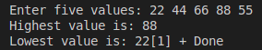
4.
#include<iostream>
#include<stdlib.h>
using namespace std;
int main()
{
int arr[50], size, pos;
cout<<"Enter array size: ";
cin>>size;
cout<<"Enter array elements: ";
for(int i=0; i<size; i++)
{
cin>>arr[i];
}
cout<<"Enter position of element to delete : ";
cin>>pos;
for(int i=pos; i<size-1; i++)
{
arr[i]=arr[i+1];
}
size--;
cout<<"New array elements are: ";
for(int i=0; i<size; i++)
{
cout<<arr[i]<<" ";
}
return 0;
}

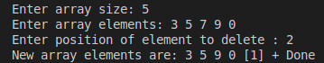
Lab Tasks
Task 1: Student Marks Management System
Scenario:
You are developing a program for a teacher who wants to store and manage student marks in an array. The
teacher needs to:
• Insert new student marks,
• Search for a particular student’s mark,
• Delete a specific mark, and
• Calculate how many marks are currently stored.
Instructions:
1. Declare an integer array to store student marks.

2. Take the number of students from the user.
3. Perform insertion to add marks into the array.
4. Implement linear search to find whether a specific mark exists.
5. Perform deletion by removing a selected mark and shifting the remaining marks.
6. Use sizeof() to find:
o The total memory used by the array.
o The number of elements stored.
7. Display the final list of marks.

Code:
#include <iostream>
using namespace std;
int main()
{
int marks[100], size, choice, mark, pos;
cout<<"Enter number of students: ";
cin>>size;

cout<<"Enter student marks: ";
for(int i=0; i<size; i++)
{
cin>>marks[i];
}

cout<<"Enter a mark to search: ";
cin>>mark;
bool found = false;
for(int i=0; i<size; i++)
{
if(marks[i] == mark)
{
cout<<"Mark found at position: "<<i<<endl;
found = true;
break;
}
}
if(!found)
{
cout<<"Mark not found."<<endl;
}

cout<<"Enter position of mark to delete: ";
cin>>pos;
for(int i=pos; i<size-1; i++)
{
marks[i] = marks[i+1];
}
size--;

cout<<"Total memory used by the array: "<<sizeof(marks)<<" bytes"<<endl;
cout<<"Number of elements currently stored: "<<size<<endl;

cout<<"Final list of marks: ";
for(int i=0; i<size; i++)
{
cout<<marks[i]<<" ";
}
cout<<endl;

return 0;
}
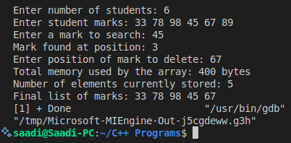

Task 2: Inventory Management System
Scenario:
You are assigned to help a shopkeeper manage product quantities.
The system should:
• Keep an array of product quantities,
• Allow insertion of a new product quantity,
• Search for a specific product quantity,
• Delete an item that is out of stock,
• Display total inventory size using sizeof().
Instructions:
1. Declare an integer array for product quantities.
2. Insert product quantities entered by the user.
3. Implement linear search to find a specific quantity (e.g., check if a product quantity of 50 exists).
4. Delete a quantity if it becomes 0 or less.
5. Use sizeof() to determine:
o Total memory allocated for all products.
o Number of products currently stored.
6. Display the updated inventory after all operation.

Code:
#include <iostream>
using namespace std;
int main()
{
int quantities[100], size, quantity, pos;
cout<<"Enter number of products: ";
cin>>size;

cout<<"Enter product quantities: ";
for(int i=0; i<size; i++)
{
cin>>quantities[i];
}

cout<<"Enter a quantity to search: ";
cin>>quantity;
bool found = false;
for(int i=0; i<size; i++)
{
if(quantities[i] == quantity)
{
cout<<"Quantity found at position: "<<i<<endl;
found = true;
break;
}
}
if(!found)
{
cout<<"Quantity not found."<<endl;
}

cout<<"Enter position of quantity to delete (if out of stock): ";
cin>>pos;
if(quantities[pos] <= 0)
{
for(int i=pos; i<size-1; i++)
{
quantities[i] = quantities[i+1];
}
size--;
cout<<"Quantity deleted."<<endl;
}
else
{
cout<<"Quantity is not out of stock."<<endl;
}

cout<<"Total memory allocated for all products: "<<sizeof(quantities)<<" bytes"<<endl;
cout<<"Number of products currently stored: "<<size<<endl;

cout<<"Updated inventory quantities: ";
for(int i=0; i<size; i++)
{
cout<<quantities[i]<<" ";
}
cout<<endl;
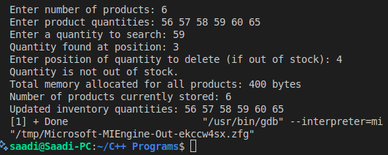
return 0;
}

